
SIMON LANGTON
Grammar School for Boys
Canterbury, Kent CT4 7AS

Tel: 01227 463567 email: office@thelangton.kent.sch.uk Headteacher Dr M N F Baxter
Fax: 01227 456486 web: www.thelangton.kent.sch.uk

Thank you for the interest you have shown in the recently advertised vacancy at the school. I hope that you find the other documentation available to you for download to be useful and informative.

I would also like to draw your attention to the school’s Mission Statement. Our aims may be lofty ones, but they are ones to which we are committed and which we are realising.

I hope that the information you have received will encourage you to apply for the post. I ask that you complete an application form and send it with a letter of about two sides of A4 explaining why you would like to be considered for the post. Please email this direct to my PA - susanbegg@thelangton.kent.sch.uk.

f you have any questions, please feel free to call me at the school, or send an e-mail to headteacher@thelangton.kent.sch.uk.

I look forward to hearing from you but, should you decide not to apply I wish you well with your career.

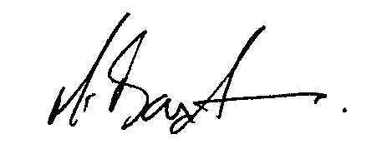
Matthew Baxter
Head Teacher

February 2008

